Project 1: Instruction Sets
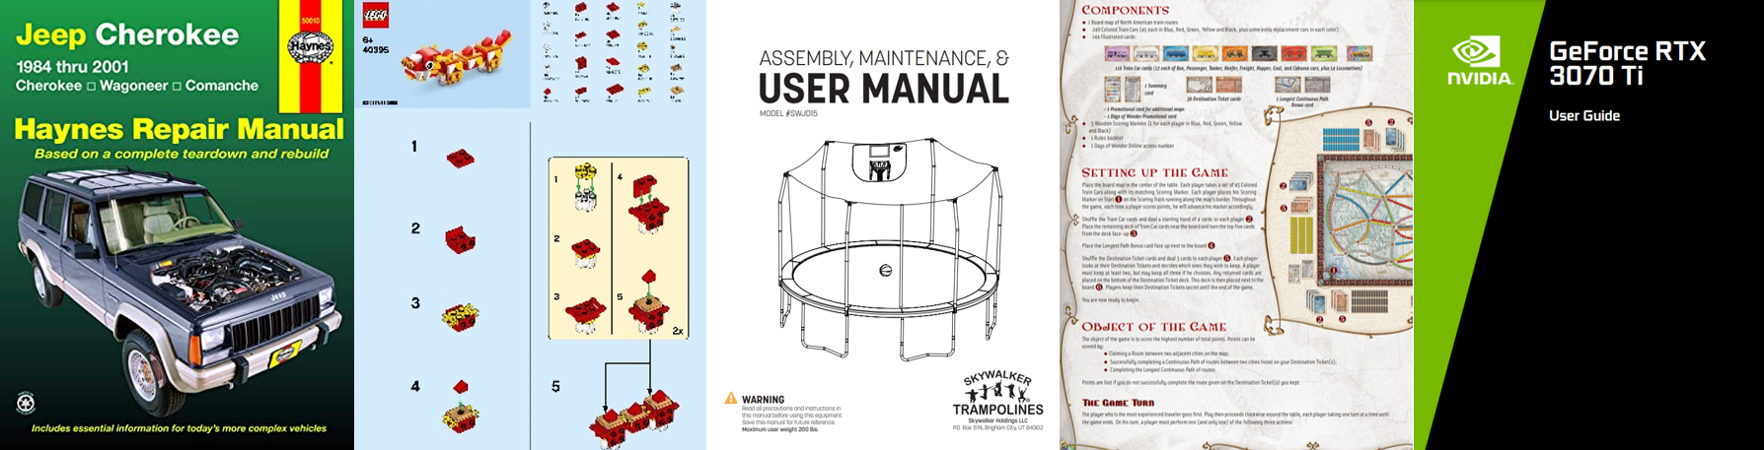

Overview
When people think of technical writing, they often think of the instruction sets in IKEA furniture or car manuals. Instruction sets are common technical documents that can be found across a wide array of occupations and disciplines. Supervisors create instruction sets for their employees so they can learn how to complete procedures; human resource departments create company policies that often serve as instructional materials; and information technology departments create “please don’t download strange files” instructional videos to (ideally) keep people from downloading viruses. It’s hard to look somewhere and not find some sort of instructional device.
Because we’re focusing on usability this semester, instruction sets are a good place to start. Audience awareness is a key component of usability; this assignment will help you in understanding the rhetorical choices that go into writing for specific audiences.
For this assignment, you will develop two (2) instruction sets that advise users to do a specific task that you consider yourself an expert in. The task should be something accessible and doable, as you will be taking your instructions and usability testing them in future projects. One instruction set should be developed for novices and one instruction set should be developed for experts.

Outcomes Met
- Communicate complex technical information, processes, and procedures via a variety of media, genres, technologies, and presentations to a range of audiences and stakeholders
- Adapt written genre conventions and expectations to both technical and non-technical audiences with changing organizational needs
- Demonstrate awareness of both the technical and human needs of users, paying special attention to accessibility, cultural diversity, and global sensitivity

Deliverables
- Project Proposal Memo
- Two (2) Instruction Sets
- Process Memo

Due Dates
Materials are due on the dates listed in Brightspace by 11:59pm ET.

DELIVERABLE DESCRIPTIONS

Project Proposal Memo
- memo format
- roughly 500 – 750 words
- an overview of the task you would like to create instruction sets for
  - the task must be something you can potentially usability test with different people in the coming weeks
  - all materials should be easily attainable (no "how to build a computer" or other complicated/expensive instructions, as that's not something we can usability test)
- how you're going to incorporate original visuals for the steps
- descriptions of what skills and characteristics each audience has
  - what makes someone a novice in this task? an expert?
- a brief statement on why you’ve selected this task
  - what makes you an expert?

Instruction Sets
- each instruction set is between 3-5 pages
- appropriate sections of instructions are included:
  - brief description (what this instruction set is for)
  - lists of materials/ingredients needed
  - chronological steps with illustrations/visuals
  - troubleshooting tips (if needed)
  - glossary of key terms/definitions (if needed)
- formatting meets expectations of an instruction set
  - heading hierarchy
  - legible and accessible fonts
  - numbered lists and bulleted lists
  - appropriate use of images and white space
  - effective use of alignment, proximity, and contrast
  - consistency in design
  - appropriate pictures to illustrate steps

Process Memo
- memo format
- roughly 500 – 750 words
- reflects on your composing process and product by considering:
  - your rhetorical goals: What were you trying to accomplish through this assignment? Did you accomplish your purpose? Why or why not?
  - the choices you made: These can be rhetorical, methodological, technological, visual, etc. What deliberate decisions did you make about what information to include and how to present it? What kinds of rhetorical concepts did you use to make sure these choices aligned with the audience, situation, and/or context for your writing? Did these choices meet the rhetorical goals you set for yourself?
  - the feedback you received: Discuss (in-depth) the revision process and how you implemented (or didn't implement) feedback from your peers and your instructor. Stating that you "didn't like the feedback" isn't enough; how did the feedback diverge from your vision if you didn't implement it? If you did implement the feedback, how did it strengthen your deliverables?

